Inlämningsuppgift 1

John Croft - 19930814-7959

1.1
sin(0.2*pi) =
0.5878
exp(2) + sin(0.3) =
7.6846
(exp(3) + cos(0.4)) / (1 + 3.4^2) =
1.6725
(3 + 2i)*(5 + 7i) =
1.0000 +31.0000i
(2 + 4i)^3 =
-88.0000 -16.0000i

1.5d
A= [1 2 3; 2 1 3; 0 2 4];
inv(A) =
0.3333 0.3333 -0.5000
1.3333 -0.6667 -0.5000
-0.6667 0.3333 0.5000

1.5g
B= [2 3 1; 0 3 6; 1 1 1]
det(B) =
9

1.6
A=[1 2 3;2 1 3;0 2 4];
B=[1;3;5];
r1=A\B =
-1.1667
-3.1667
2.8333
C=[2 5 1 2; 0 -3 2 3; 2 1 0 0; 3 3 3.2 -3];
D=[2; 1; 10; 3];
r2=C\D =
5.7937
-1.5874
-2.5733
0.4615
1.7
A=[1 4 3; 3 0 3; -2 1 -2; 4 3 7; 0 3 3];
B=[9.2; 5.8; -4.3; 14.5; 5.7];

r = A\B =
1.4500
1.2400
0.7350

1.8
% x^3 + 2x^2 + 3x + 1
x1= roots([1 2 3 1]) =
-0.7849 + 1.3071i
-0.7849 - 1.3071i
-0.4302 + 0.0000i

% 5x^5 + 3x^4 + 1.5x^3 +2x + 4
x2 = roots([5 3 1.5 0 2 4]) =
-0.9090 + 0.0000i
-0.4994 + 0.8926i
-0.4994 - 0.8926i
0.6540 + 0.6431i
0.6540 - 0.6431i

% 3x^8 + 1
x3 = roots([3 0 0 0 0 0 0 0 1]) =
-0.8053 + 0.3336i
-0.8053 - 0.3336i
-0.3336 + 0.8053i
-0.3336 - 0.8053i
0.3336 + 0.8053i
0.3336 - 0.8053i
0.8053 + 0.3336i
0.8053 - 0.3336i

1.9
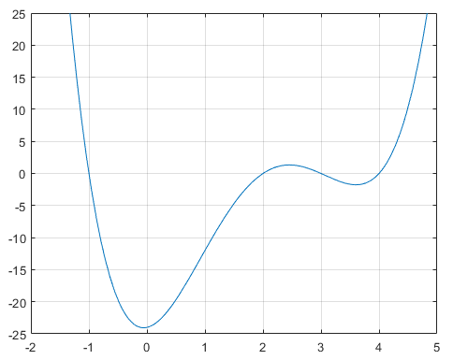
Fig 1: Utskrift från 1.9. Rötterna stämmer överens med dem angivna av vektorn x.
x = [-1; 2; 3; 4];

syms t
p = poly2sym(poly(x), t) =
t^4 - 8*t^3 + 17*t^2 + 2*t - 24

1.15

for x=[500 2000]
a=0;
for y = 0:x
a = a+y;
end
a
end

a = 125250
a = 2001000

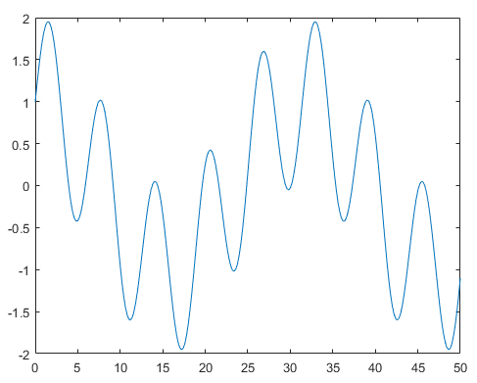
Fig 2: Utskrift från 1.18
1.18
x = 0:0.2:50;
f1 = sin(x) + cos(0.2.*x);
plot(x, f1)

1.19
subplot(2, 2, 1), plot(x, sin(x))
subplot(2 ,2 ,2), plot(x, cos(x))
subplot(2, 2, 3), plot(x, sin(.5.*x))
subplot(2, 2, 4), plot(x, cos(.5.*x))
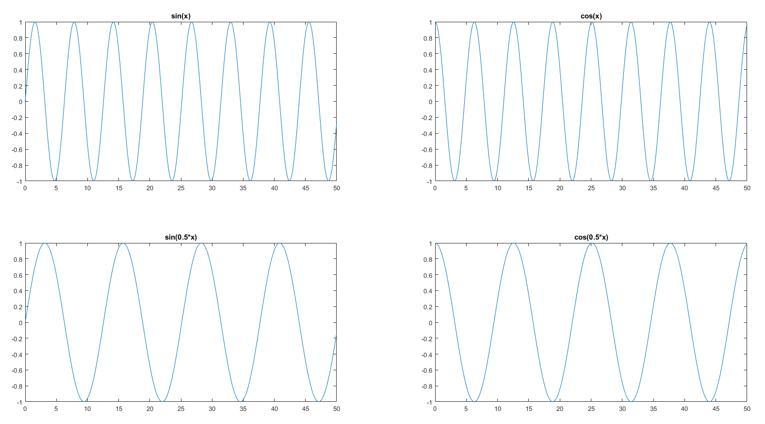
Fig 3: Utskrift från 1.19
1.23
function delning(A)
input_var = input('Ge ett reellt tal: ');
if input_var == 0
disp('Math Error!')
else
disp(A./input_var)
end

